**Camso remove unreferenced files**



Version V1.0

**SUBMITTED BY**

**ITC INFOTECH INDIA LTD**

**Reviewed and Accepted by**

**Project/Program Manager Project Manager**



**ITC Infotech**

**(**[**http://www.itcinfotech.com**](http://www.itcinfotech.com/)**)**

|  |
| --- |
| **Trademark Acknowledgement** |

Copyright© 2014 ITC InfoTech

All products or brand names used in this document are trademarks or registered trademarks of their respective companies.

ITC InfoTech shall not be liable for errors contained herein, or for consequential damages in connection with the furnishing, performance or use of the material. No part of this document may be reproduced or transmitted in any form or by any means, for any purpose, or translated to another language without the prior written consent of ITC InfoTech.

|  |
| --- |
| **Confidentiality Statement** |

By accepting this document the recipient agrees:

* To keep permanently confidential all information which it contains.
* To treat and retain as secret and confidential all information contained in this document or otherwise acquired by the receiving party from ITC InfoTech including, without prejudice to the generality of the foregoing, all handbooks, manuals, drawings, designs, specifications, charts, diagrams, tapes, disks, diskettes, and any other documents or materials containing such information.

# Preface

The purpose of this document is to describe deployment process for removing unreferenced files.

1. Go to Site🡪 Utilities🡪 File Server Administration🡪 Vault Configuration.
2. Select the replica vault.

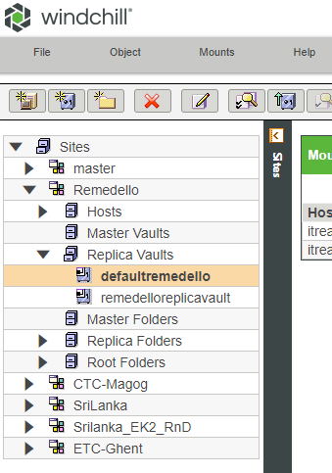

1. Go to OPTIONS and click on Remove Unreferenced Files.

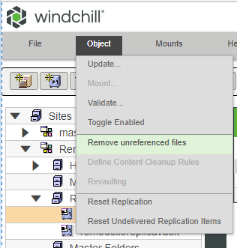

1. You will get a dialogue box.

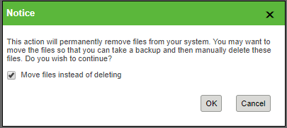

**Note:** Always check the ‘Move files instead of deleting’ checkbox or else the files will be permanently deleted and cannot be recovered.

1. Then click on OK

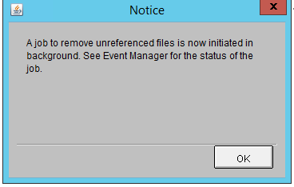

1. We can check the status by going to Quick Links🡪 Event Management

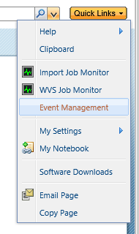

1. The status will initially be pending.
2. We can see the .unreferenced folder in the mounted path and inside the vault folders.

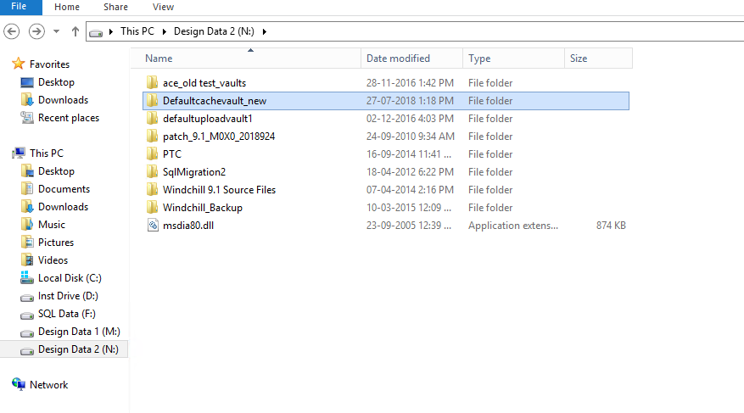

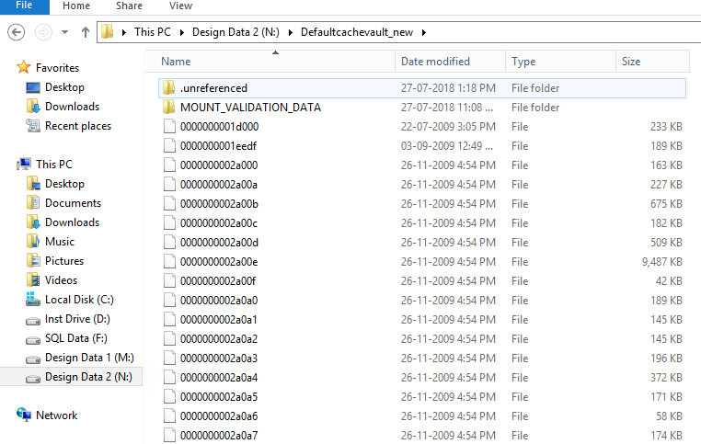

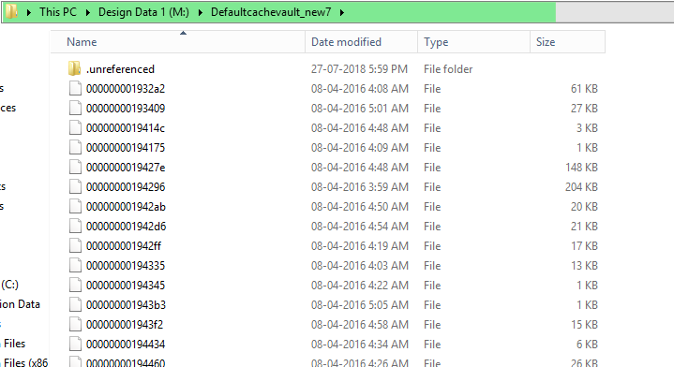

1. The status will be successful once the utility has been completed.
2. Login to any replica server. Run the moveUnref batch file to move all the unreferenced files to the “Unref” folder.

